**Software Requirements Specification**

DISPLAY BOOKSHELVES PROJECT

|  |  |  |  |
| --- | --- | --- | --- |
|  | Prepared By | Reviewed By | Approved By |
| Name | Anand Kumbar | Ventakataraman |  |
| Role | Intern | Batch Trainer |  |

**Table of Contents**

Table of Contents…………………………………………………………..….......II

1. Introduction…………………………………………………………………..…1

1.1 Intended Audience……………………………………………….......1

1.2 Project Scope…………………………...……………………………1

2. Overall Description…………………………………………….……………….1

2.1 Operating Environment……………………...……………………....1

3. Requirements……………………………………………………………...…….1

3.1Login………………………………………………………………….2

3.1.1Description………………………………………………....2

3.1.2 Functional Requirements……..…………………………...2

**1. Introduction**

Coursera is an online learning website. We are taking and testing one functionality of that website (i.e.) Searching for Web Development courses. and also extract the look for the language learning

**1.1 Intended Audience**

Business Unit (BU) SME

Academy coach

Technical Trainer

**1.2 Project Scope**

This document defines at a functional level the business activities that are encompassed by the system and the rules that apply to them. It also encompasses some of the key high- and low-level technical requirements of the system.

It draws heavily on both proposed Framework and Business Rules and the Technical Architecture documents. The scope of the detailed analysis project phase specifies that this document will include.

· Classification of requirements according to their functional areas.

· A description of each process in the system, including their inputs, outputs, and data transformation rules.

**2. Overall Description**

**2.1 Operating Environment**

Windows operating system

Web application

**3. Requirements**

This part of the requirements document serves to present the "Coursera for web development courses" of the application and also, we need to extract all the levels in “Language Learning”.

**3.1.1 Functional Requirements**

**3.1.1.1 Req0001**

**Req0001a-**The user clicks on “Bookshelves” from study the dropdown.

**Req0001b**- Signup pop will be displayed and close the popup.

**Req0001c-**The user selects Exclude “Out of Stock” and “Storage Type” filter

from the page.

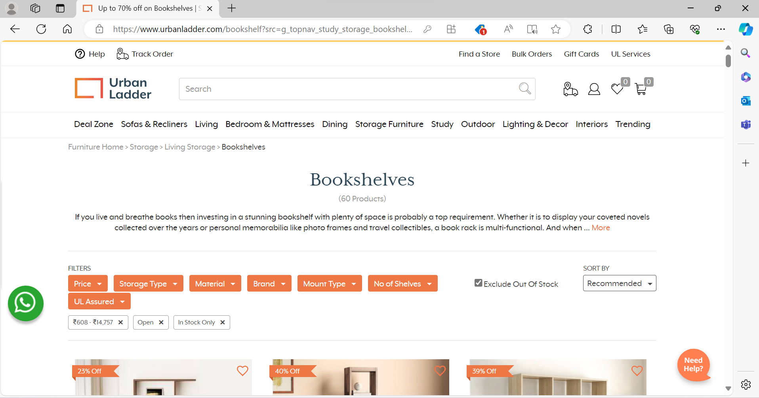

**Req0001d-** The user collects “name and price” of the first 3 Bookshelves

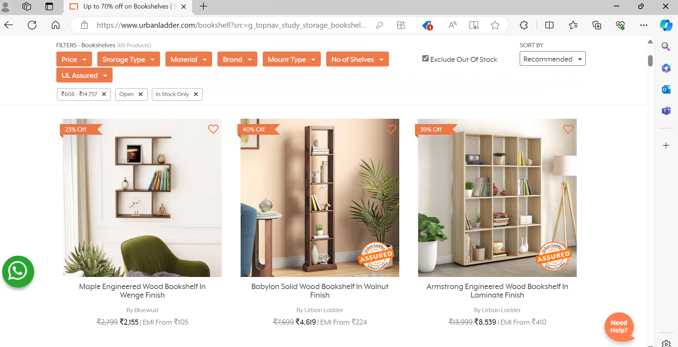

**3.1.1.2 Req0002**

**Req0002a**- The user clicking on the “Trending”.

**Req0002b-** The user selects “UL Collections” from the dropdown.

**Req0002c-** The user clicks on the “Category”.

**Req0002d**- Extract sub-menu items.

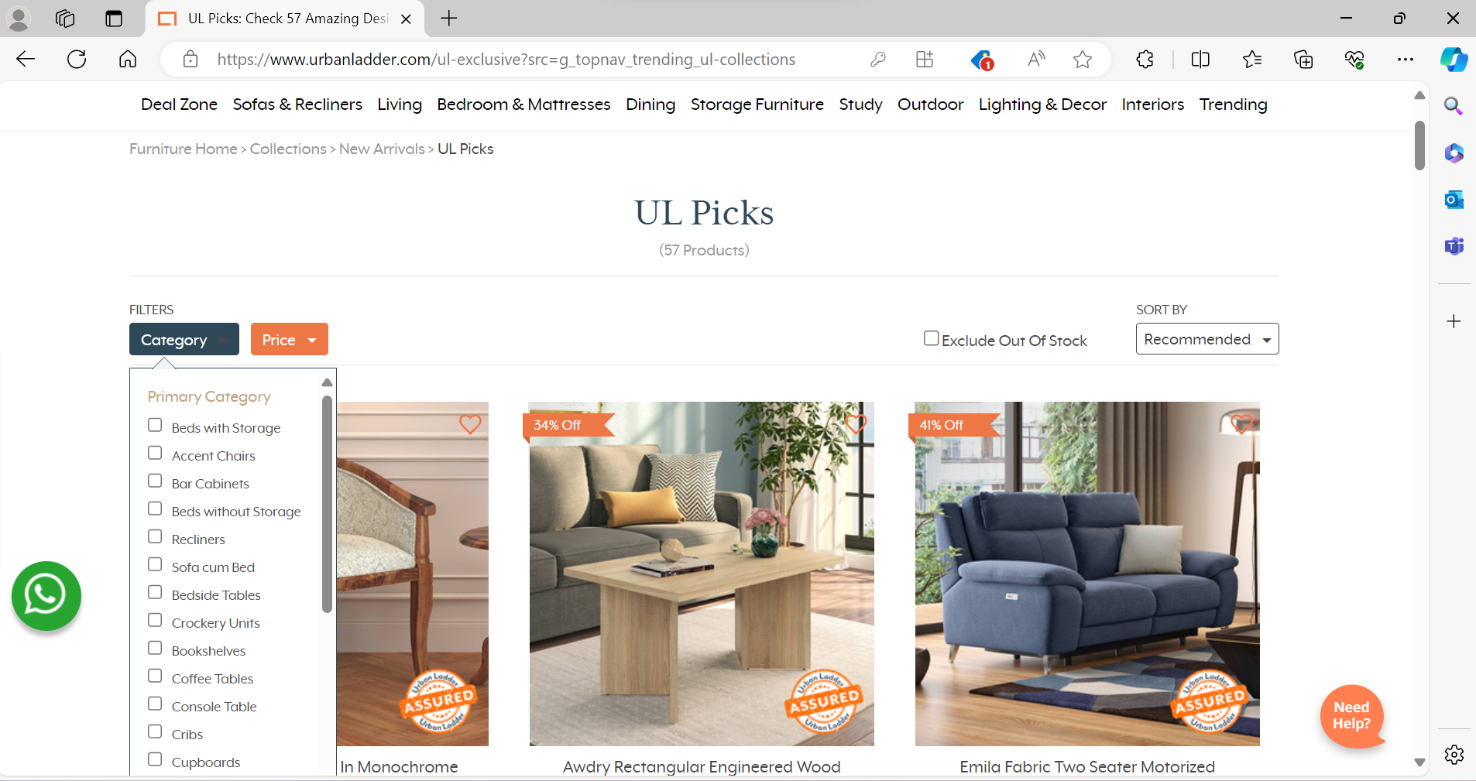

**3.1.2.3 Req0003**

**Req0003a**- The user needs to click on the “Gift Card”.

**Req0003b-** The user hovers over the “Birthday/Anniversary”

**Req0003c-** The user Click on the “Chosen”, “Amount” and “next button”.

**Req0003d-** The user fills the form with any one invalid input and capture the error message.

